**DOCUMENTATION** for LeanAgriProject:

Github link: <https://github.com/garimamangalhara/LeanAgriProject>

Heroku deployed app link: <https://lean-agri-project.herokuapp.com/>

This web application consists of 4 pages:

1. The Main Page(List of all the posts):

* All the posts are displayed on this page.
* There is a “Create” button which will redirect to the create page.
* There is an “Update” button which will redirect to the Update Page.
* If you click on any post, it will redirect to the details page.

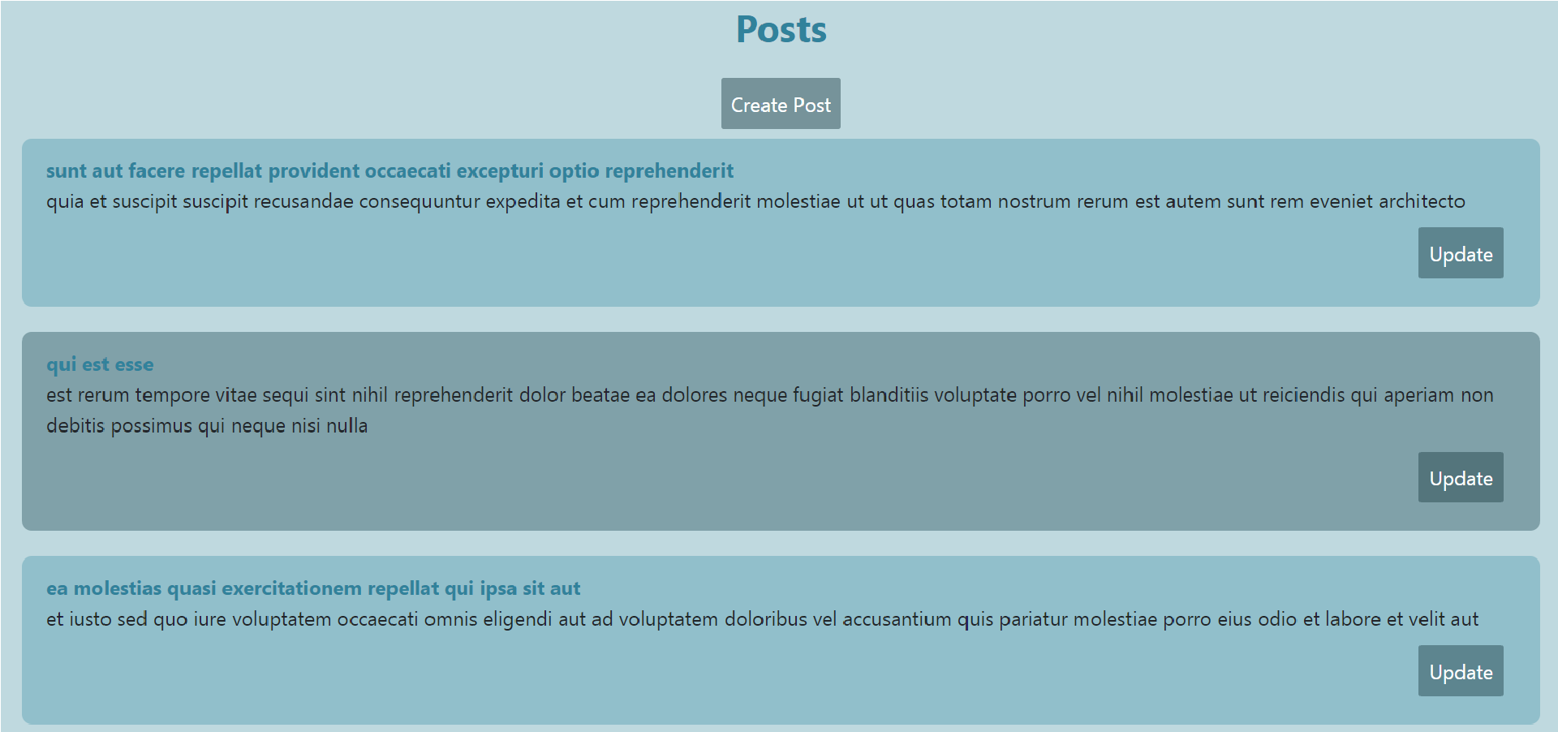

1. The details Page(Details and all the comments of a post):

* You can see the details and comments of the post you clicked on.

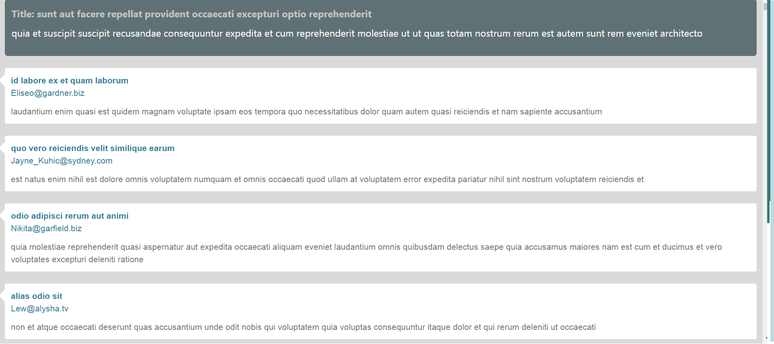

1. Create Page(Create a new post):

* You can create a new post here.
* Atleast one field is required to create a new post.



1. Update Page(Update an existing page):

* You can update a post here.
* Atleast one field is required to update the post.

